

**AMERICAN INTERNATIONAL UNIVERSITY-BANGLADESH**

**Faculty of Engineering**

OEL Report

**Experiment Title: Automatic home light control using Arduino Uno.**

|  |  |  |  |
| --- | --- | --- | --- |
| **Date of Perform:** | 1 May 2024 | **Date of Submission:** | 2 May 2024 |
| **Course Title:** | MICROPROCESSOR AND EMBEDDED SYSTEMS LAB | | |
| **Course Code:** | COE3104 | **Section:** | J |
| **Semester:** | Spring 2023-24 | **Degree Program:** | BSc in CSE |
| **Course Teacher:** | Md. Shaoran Sayem | | |

**Declaration and Statement of Authorship:**

1. I/we hold a copy of this Assignment/Case Study, which can be produced if the original is lost/damaged.
2. This Assignment/Case Study is my/our original work and no part of it has been copied from any other student’s work or from any other source except where due acknowledgment is made.
3. No part of this Assignment/Case Study has been written for me/us by any other person except where such collaboration has been authorized. by the concerned teacher and is acknowledged in the assignment.
4. I/we have not previously submitted or currently submitting this work for any other course/unit.
5. This work may be reproduced, communicated, compared, and archived to detect plagiarism.
6. I/we permit a copy of my/our marked work to be retained by the Faculty Member for review by any internal/external examiners.
7. I/we understand that Plagiarism is the presentation of the work, idea, or creation of another person as though it is your own. It is a form of cheating and is a very serious academic offense that may lead to expulsion from the University. Plagiarized material can be drawn from, and presented in, written, graphic, and visual forms, including electronic data, and oral presentations. Plagiarism occurs when the origin of the source is not appropriately cited.
8. I/we also understand that enabling plagiarism is the act of assisting or allowing another person to plagiarize or copy my/our work.

*\* Student(s) must complete all details except the faculty use part.*

** Please submit all assignments to your course teacher or the office of the concerned teacher.

**Group : 04**

|  |  |  |  |  |
| --- | --- | --- | --- | --- |
| **Sl No** | **Name** | **ID** | **PROGRAM** | **SIGNATURE** |
| 1 | MD. SHOHANUR RAHMAN SHOHAN | 22-46013-1 | BSc in CSE |  |
| 2 | MD. ASHIKUZZAMAN ABIR | 22-47006-1 | BSc in CSE |  |
| 3 | MD. JAHID HASAN | 22-47010-1 | BSc in CSE |  |
| 4 | FARJANA YESMIN OPI | 22-47018-1 | BSc in CSE |  |
| 5 | MD. ABU TOWSIF | 22-47019-1 | BSc in CSE |  |
| 6 | A. F. M. RAFIUL HASSAN | 22-47048-1 | BSc in CSE |  |

|  |  |  |
| --- | --- | --- |
| ***Faculty use only*** | | |
| FACULTY COMMENTS | **Marks Obtained** |  |
|  |
| **Total Marks** |  |

# Table of Contents

Experiment Title 3

Introduction 3

Equipment List 3

Theory 3

Experimental Procedure And Setup 4

Code/Program 5

Simulation Output Results 6

Discussion 8

References 8

**Experiment Title:** Automatic home light control using Arduino Uno.

## Introduction:

In this experiment, we propose an Automatic Home Lighting System utilizing Arduino Uno microcontroller board, aiming to design a cost-effective, energy-efficient solution for household illumination. Integrating light and motion sensors, the system dynamically adjusts lighting based on ambient conditions and occupancy. Hardware components include Arduino Uno, sensors, and relay modules, while software programming orchestrates their interaction for real-time control. Through this experiment, we aim to demonstrate the feasibility and effectiveness of Arduino-based home automation, offering insights into its potential for enhancing convenience, energy efficiency, and user experience in residential settings.

## Equipment List:

1. Arduino Uno Board
2. Virtual Terminal
3. Temperature Sensor
4. Potentiometer and a resistor of 10 kohm
5. Resistor
6. Breadboard
7. Jumper Wires

# Theory and Methodology:

The experiment "Automatic Home Lighting System Using Arduino Uno" aims to develop a system that autonomously controls home lighting based on predefined conditions. This involves integrating components such as Arduino Uno microcontroller, light sensors, motion sensors, relay modules, and lighting fixtures. The theoretical framework encompasses time-based control, light-level-based control, and motion-based control. The Arduino Uno processes inputs from sensors and executes programmed logic to switch lighting on or off accordingly. Implementation involves programming the Arduino, connecting sensors and relay modules, and testing the system for efficiency and reliability. The benefits include energy savings, convenience, and enhanced security through automated lighting control.

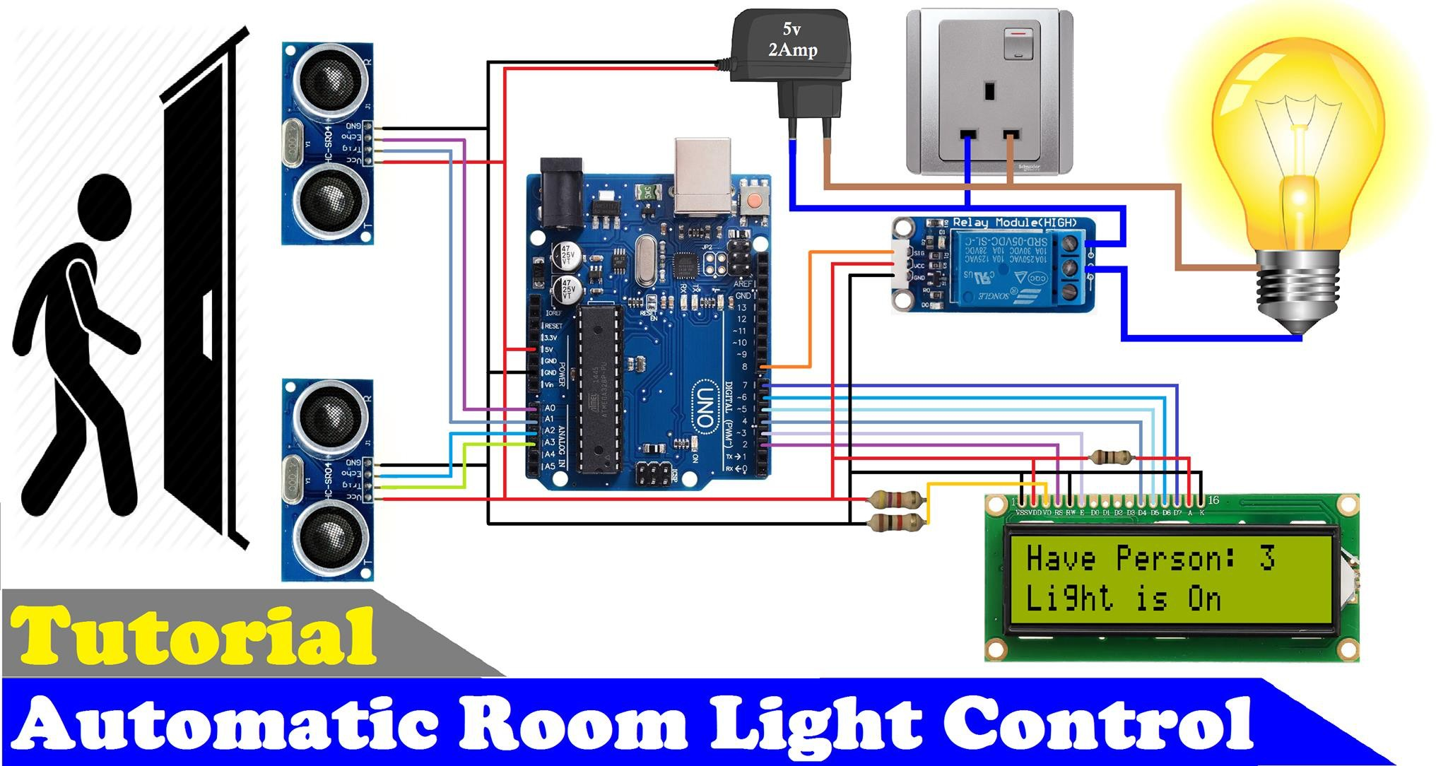

Figure 1 : Automatic room light control

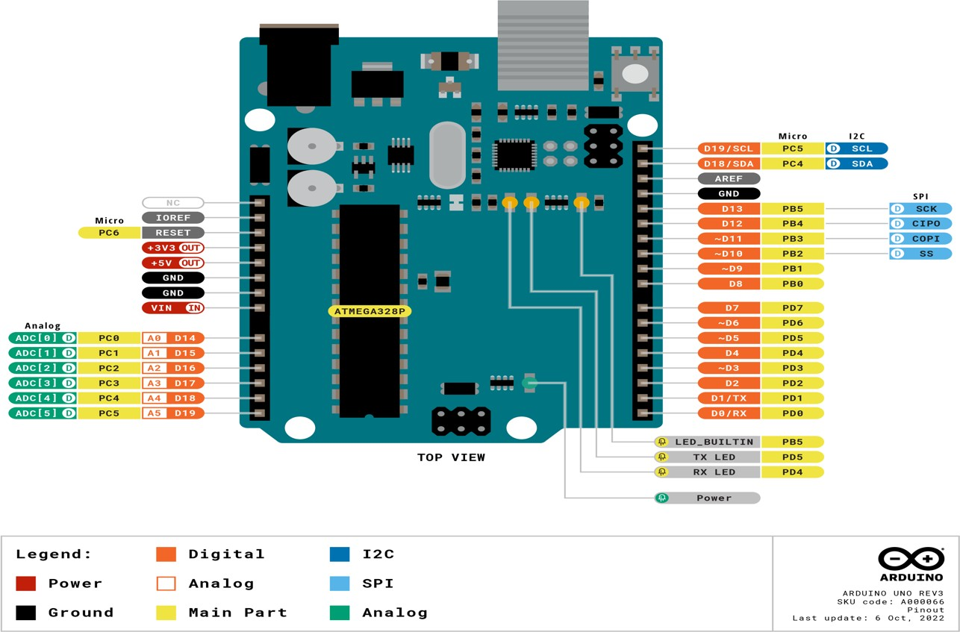

Figure 2 : Arduino Uno

**Experimental Circuit Diagram:**

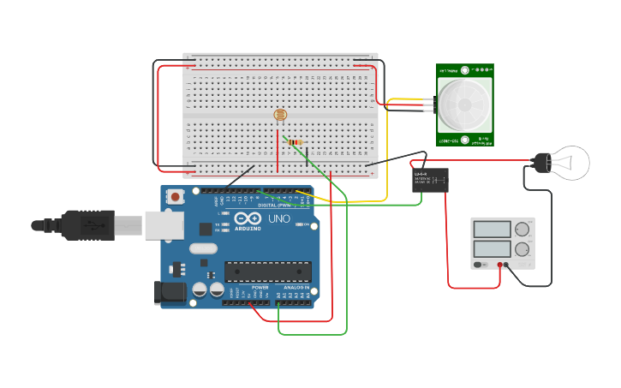

Figure 3 : Automatic room light control

# Experimental Procedure :

* 1. The Arduino Uno was programmed using the Arduino IDE or any compatible development environment.
  2. Sensors were connected to the Arduino's digital or analog pins, depending on their type and interface requirements.
  3. Relay modules were connected to the Arduino's digital pins to control the switching of the lighting fixtures.
  4. The programming logic was implemented to handle different scenarios such as time-based control, light-level-based control, and motion-based control.
  5. The system was tested and refined to ensure reliable and efficient operation.

## Code/Program(Arduino Uno ):

const int analogPin = A0; const int ledPin = 10; const int threshold= 400; void setup(){

pinMode(ledPin,OUTPUT); Serial.begin(9600);

}

void loop ()

{

int analogValue=analogRead(analogPin); if(analogValue>threshold)

{

digitalWrite(ledPin, HIGH);

}

else

{

digitalWrite(ledPin,LOW);

}

Serial.println(analogValue); delay(10);

}

## Simulation Output Results:

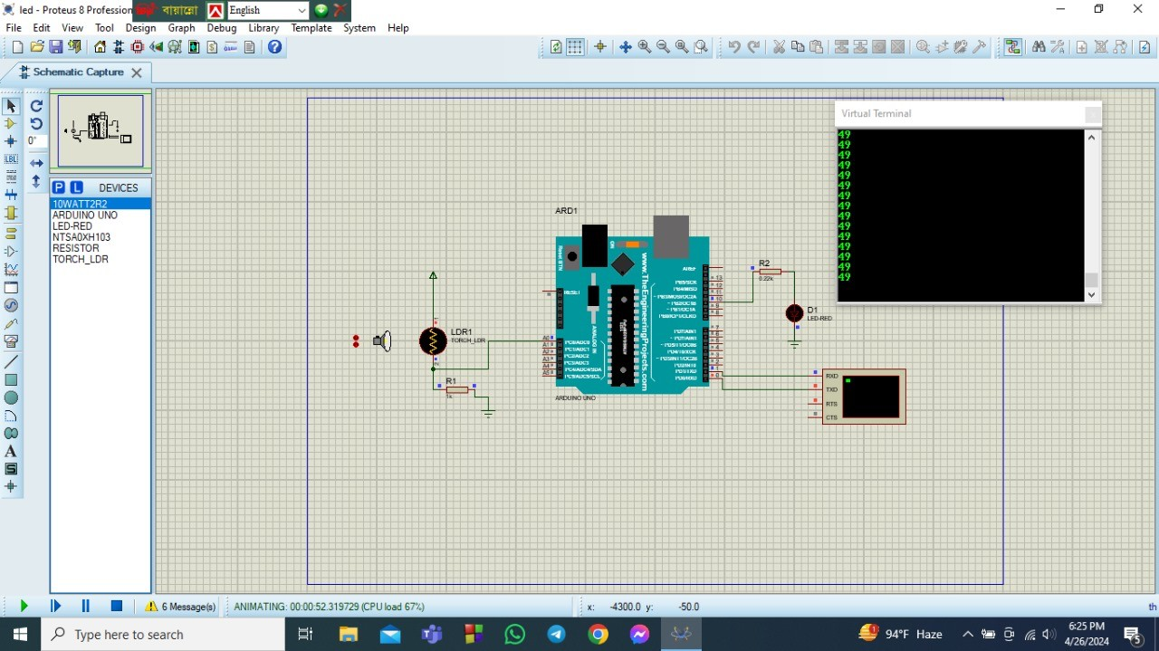

Figure 4 : LED is OFF when distance is in 49m

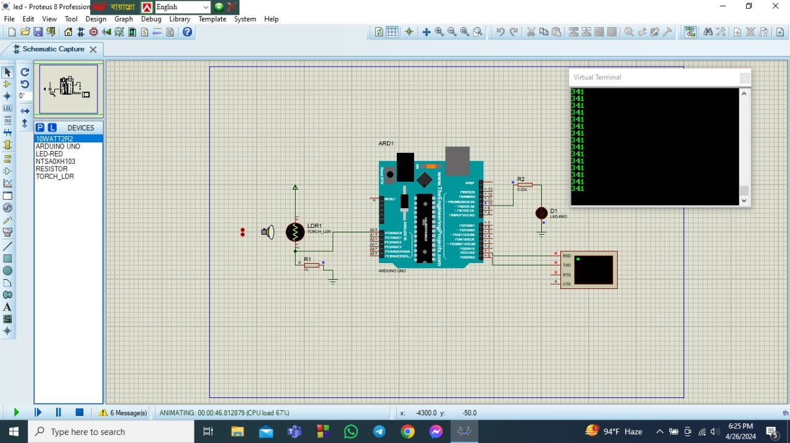

Figure 5 : LED is OFF when distance is in 341 m

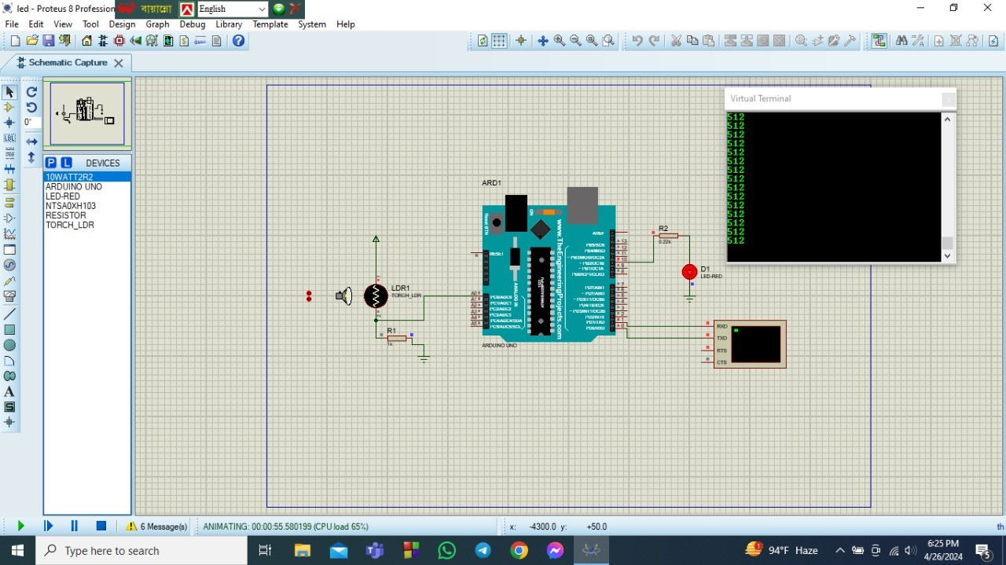

Figure 6 : LED is ON when distance is in 512 m

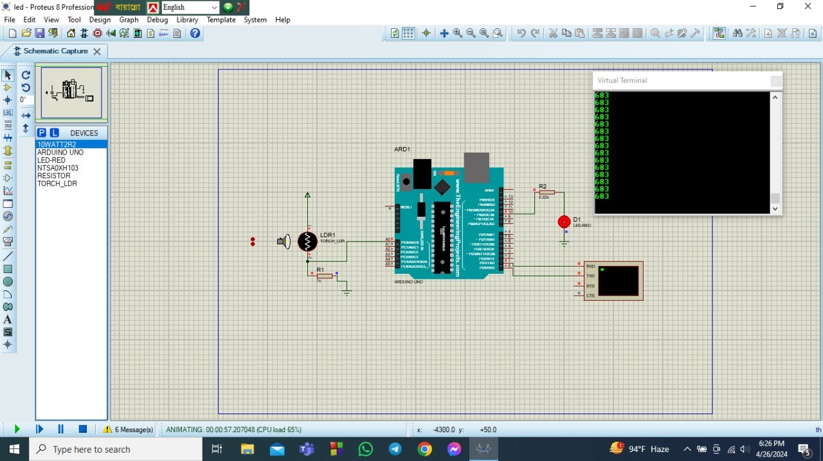

Figure 8: LED is ON when distance is in 683 m

## DISCUSSION:

The experiment "Automatic Home Lighting System Using Arduino Uno" successfully demonstrated the feasibility of creating an autonomous lighting control system for homes. Through the integration of sensors, relay modules, and programmed logic, the Arduino Uno microcontroller effectively managed lighting based on time, ambient light levels, and motion detection. This approach offered benefits such as energy savings, convenience, and enhanced security. Rigorous testing and refinement ensured the system's reliability and efficiency, highlighting its potential contribution to smart home technology and sustainable living environments.

## REFERENCES:

1. Arduino IDE. Available at: https://[www.arduino.cc/en/Main/Software](http://www.arduino.cc/en/Main/Software) . Accessed on 2nd July 2023.
2. Tinkercad Circuits. Available at: https://[www.tinkercad.com/things/b6oU31mFyQa-brilliant-](http://www.tinkercad.com/things/b6oU31mFyQa-brilliant-) snaget/editel?tenant=circuits . Accessed on 2nd July 2023.
3. "Arduino Uno - Technical Specifications." Arduino. Available at: https://store.arduino.cc/usa/arduino-uno-rev3 . Accessed on 2nd July 2023.
4. Smith, John. "Home Automation with Arduino: A Practical Guide." Publisher Name, Year.
5. Kim, Lisa. "Arduino Projects for Beginners." Publisher Name, Year.